Tables and Display Equipment 2026
Aluminium display table complete with header.
Excluding Transport - £530.00 per table
This display table offers a sleek and professional solution to displaying water plants, complete with flood tray and header. Point of sale created with continuity in mind, colour schemes and design elements complement each other to showcase aquatics in a modern and eye-catching way.
Dimensions: 228x116x74cm (3 per trolley) Transport charged at cost £60 per cc trolley.
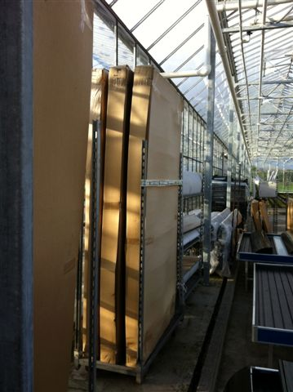
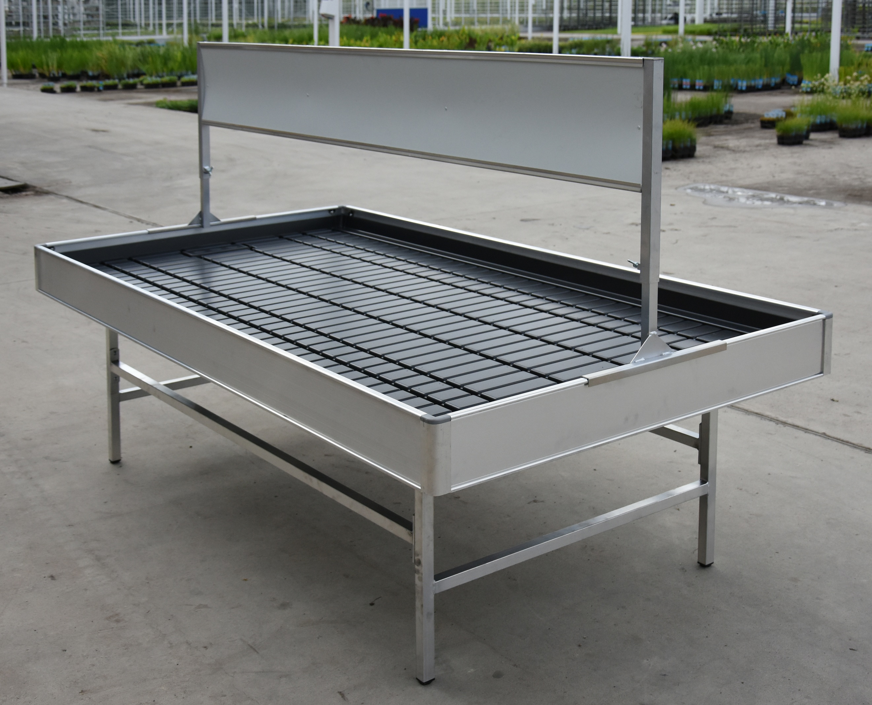
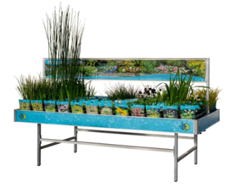

Themed Header Posters.

£29.50 each or one free with every table purchased. (Prices exclude transport costs) 4 Themed headers are available to complement the displays. Offering brand continuity with a modern finish, these premium header boards add the finishing touch to any new display.
- Water Plants

- Oxygenating Plants
- Waterlilies

- Native Plants



Table Side Banners
£29.50 for a set of 4
2 Long and 2 short side banners. Further offering brand continuity


